WSIPC Enhanced Skyward PaC Finance

WESPaC Human Resources
Job Aid

Manual Retro Contract Payment

Manual Retro Contract Payment Steps
- The information below provides the steps and setup information necessary to manually process a retro payment.
- Use this process in the conversion year when some payrolls were in legacy and some payrolls were in WESPaC. This process may also be required if a contract is added and retro needs to be paid for prior periods in the month the contract is added.
- Make the salary changes in Employee Management (EMS) and then use the Assignment Export/Payroll Import Utility.
In this example, Adam Minn’s salary will change from $83,000 to $83,500. He will receive one retro payment.

- Find the employee assignment that needs to be changed.

Select the Payroll button.

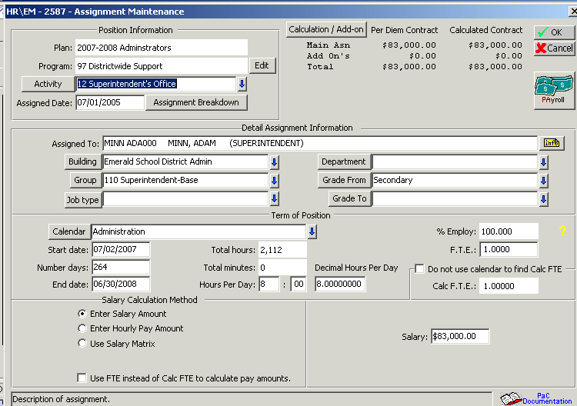

- Make note of the current contract annual amount (Calculated Contract) and the monthly amount (Per Pay Period).

You will want to know what the original annual and monthly amounts were. You will use this information to figure the difference between the old amount and the new amount (more on this later).

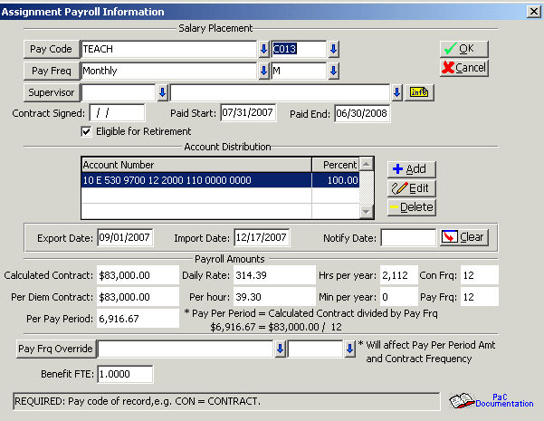

This is the contract prior to any adjustment:

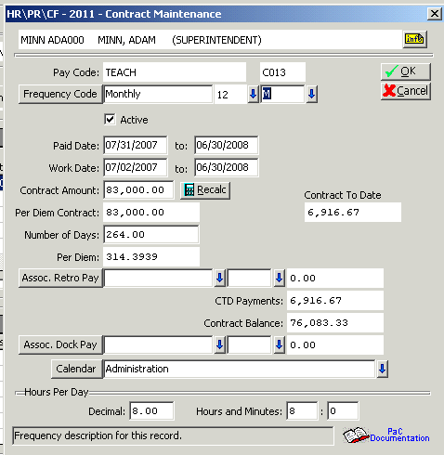

- Enter the new salary amount or adjust the placement tracker on the employee’s assignment.

In this example, the salary was changed to $83,500.00 (from the $83.000.00).

Select the Payroll button after the salary has been changed.

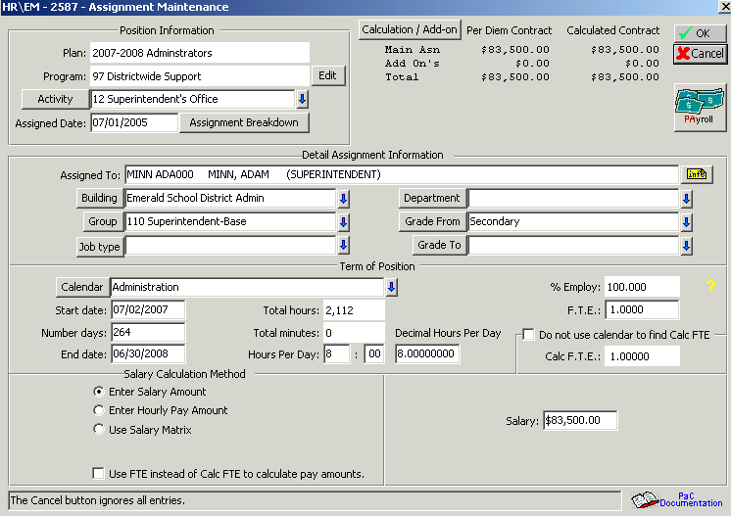

- See the updated contract annual amount (Calculated Contract) and the monthly amount (Per Pay Period).

Original Contract Amount = 83,000
New Contract Amount = 83,500

Original Monthly Amount = 6,916.67
New Monthly Amount = 6,958.33

The monthly difference is 41.66 (6,958.33 – 6,916.67).

How many months were already paid at the original 6,916.67 amount?
Let’s say it is 1 month for this example.

1 month times 41.66 is the amount of the retro pay record we will create later.

Select the OK button.

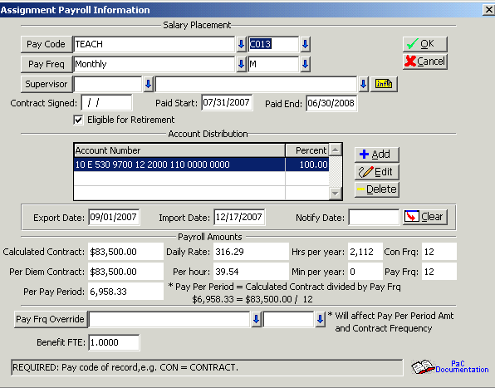

- Select the OK button on the Assignment Maintenance screen.

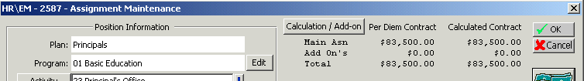

- The system will display the Clear Export/Import Dates message if the assignment has export or import dates. The example Assignment Payroll Information screen above does not have any dates in the export or import date fields.

Select the Yes button.

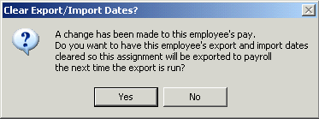

- Select the Assignment Export/Payroll Import utility process and select the Run button.

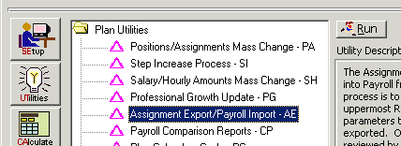

The Job Aid for EMS Assignment Export Import provides more details about the settings for the export and import.

- Select the Run button on the Assignment Export Process.

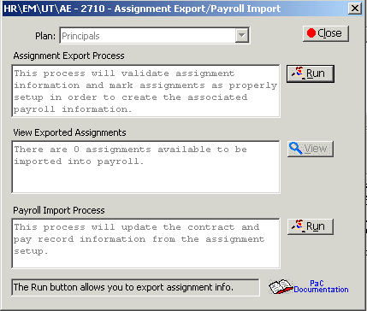

- Use the Select Parameters button to select just those people you want to export.

The detailed steps for the Select Parameters options are not shown in this example.

Then Select the Run button.

Review and Save the Export from EMS report.

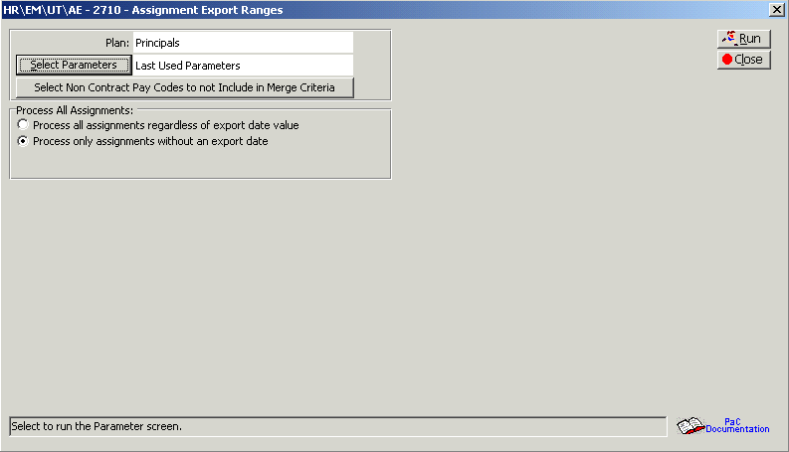

- This screen displays after the Export from EMS report is saved (or closed).

Select the Yes button to continue.

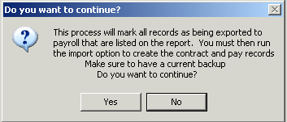

- This example had just one assignment exported. You can see that in the middle part of this screen in the View Exported Assignments area.

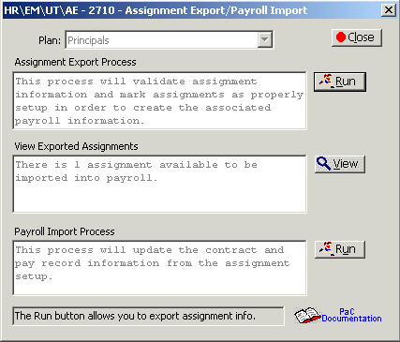

- Select the Run button for the Payroll Import Process.

- Payroll Import settings would generally have the defaults.

The Pay Record Creation Option is important.
Select the second radio button (If pay record exists ...).

Select the Run button.

Review and Save the Import into Payroll report.

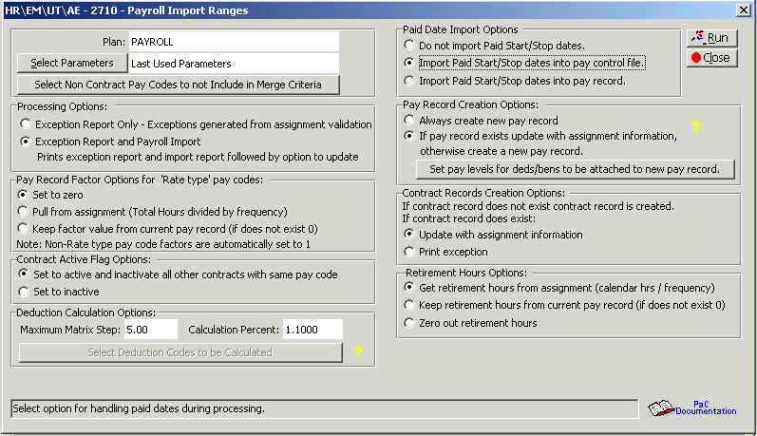

- This screen displays after the Import into Payroll report is saved (or closed).

Select the Yes button to continue.

An Exception report will display.

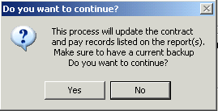

- Add Retro Pay Code. Apply mandatory Ded\Bens (including retirement). Enter the retro amount and a factor of 1. The Paid Start/Stop Dates will vary depending on the number of retro payments you are making.

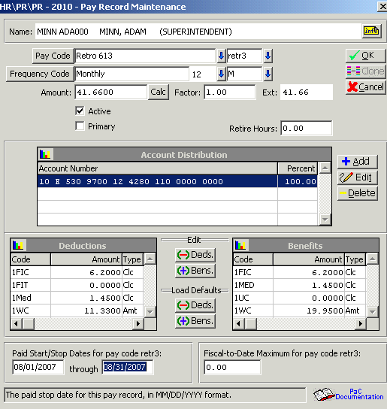

- Enter Retro Pay Code in Contract. Leave the amount blank:

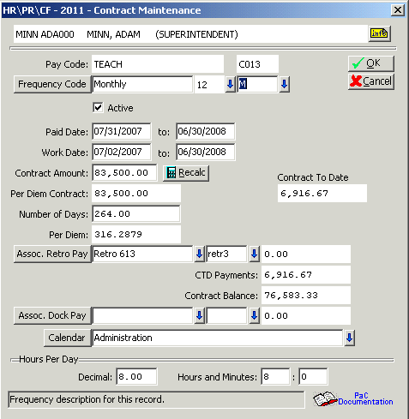

- Process Payroll. Select the contract and retro pay records for payment.

- The amount on the Assoc. Retro Pay area on the Contract Maintenance screen will not be there until after the payroll process is through the update step. This amount should match the amount of the retro pay record.

The CTD Payments field displays the sum of all payments on the contract pay code plus retro pays. The "Contract Balance" field correctly displays the amount owed to the employee and should be used for reference instead of subtracting the Contract Amount minus Contract Payments.

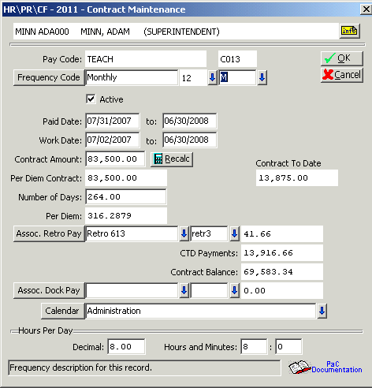

On the Con/Flx tab, the Contract To Date Amount column is displaying the sum of all updated payments to this person using only their contract pay code. It does not include Retro or Dock pays. Because of this, the "Contract To Date" field will never equal the Contract Amount if Retro pay is used during that year.

The Contract Balance, however, accurately reflects what is actually owed to them (Contract Pays -Retro Pays). It will be zero at the end of the year.

